Solution of velvet cracking in finished sofa
The velvet is woven, which is different from the warp knitted fabric, pls see below schematic diagram of fabric structure.
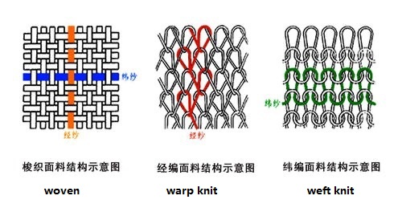
When making the product, leave as much space as possible on the edge of the cloth or stitch the double thread, so as to avoid the collapse or tear when adding the last sewing thread. Because the stressed area becomes smaller when the edge of the cloth is stitched, it is easy to pull out the transverse bottom part without stitch the double thread, resulting in the cracks of the finished product.
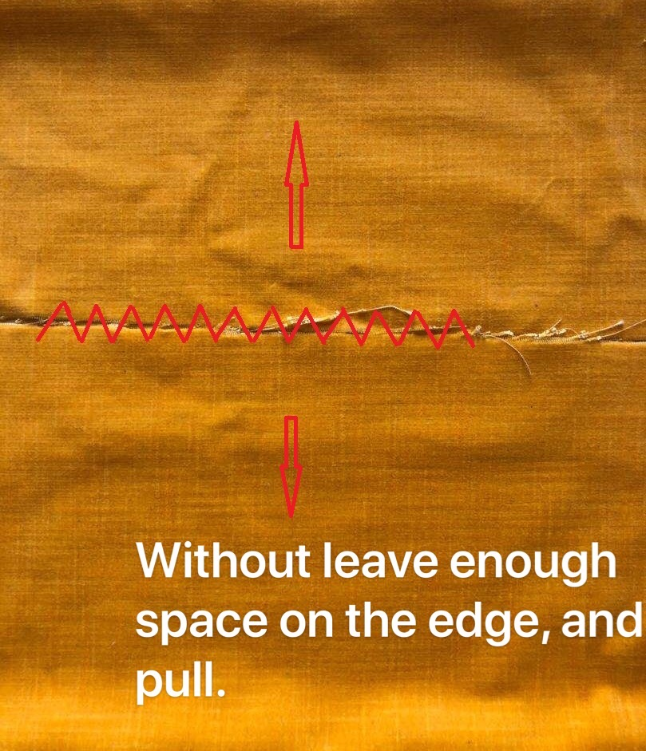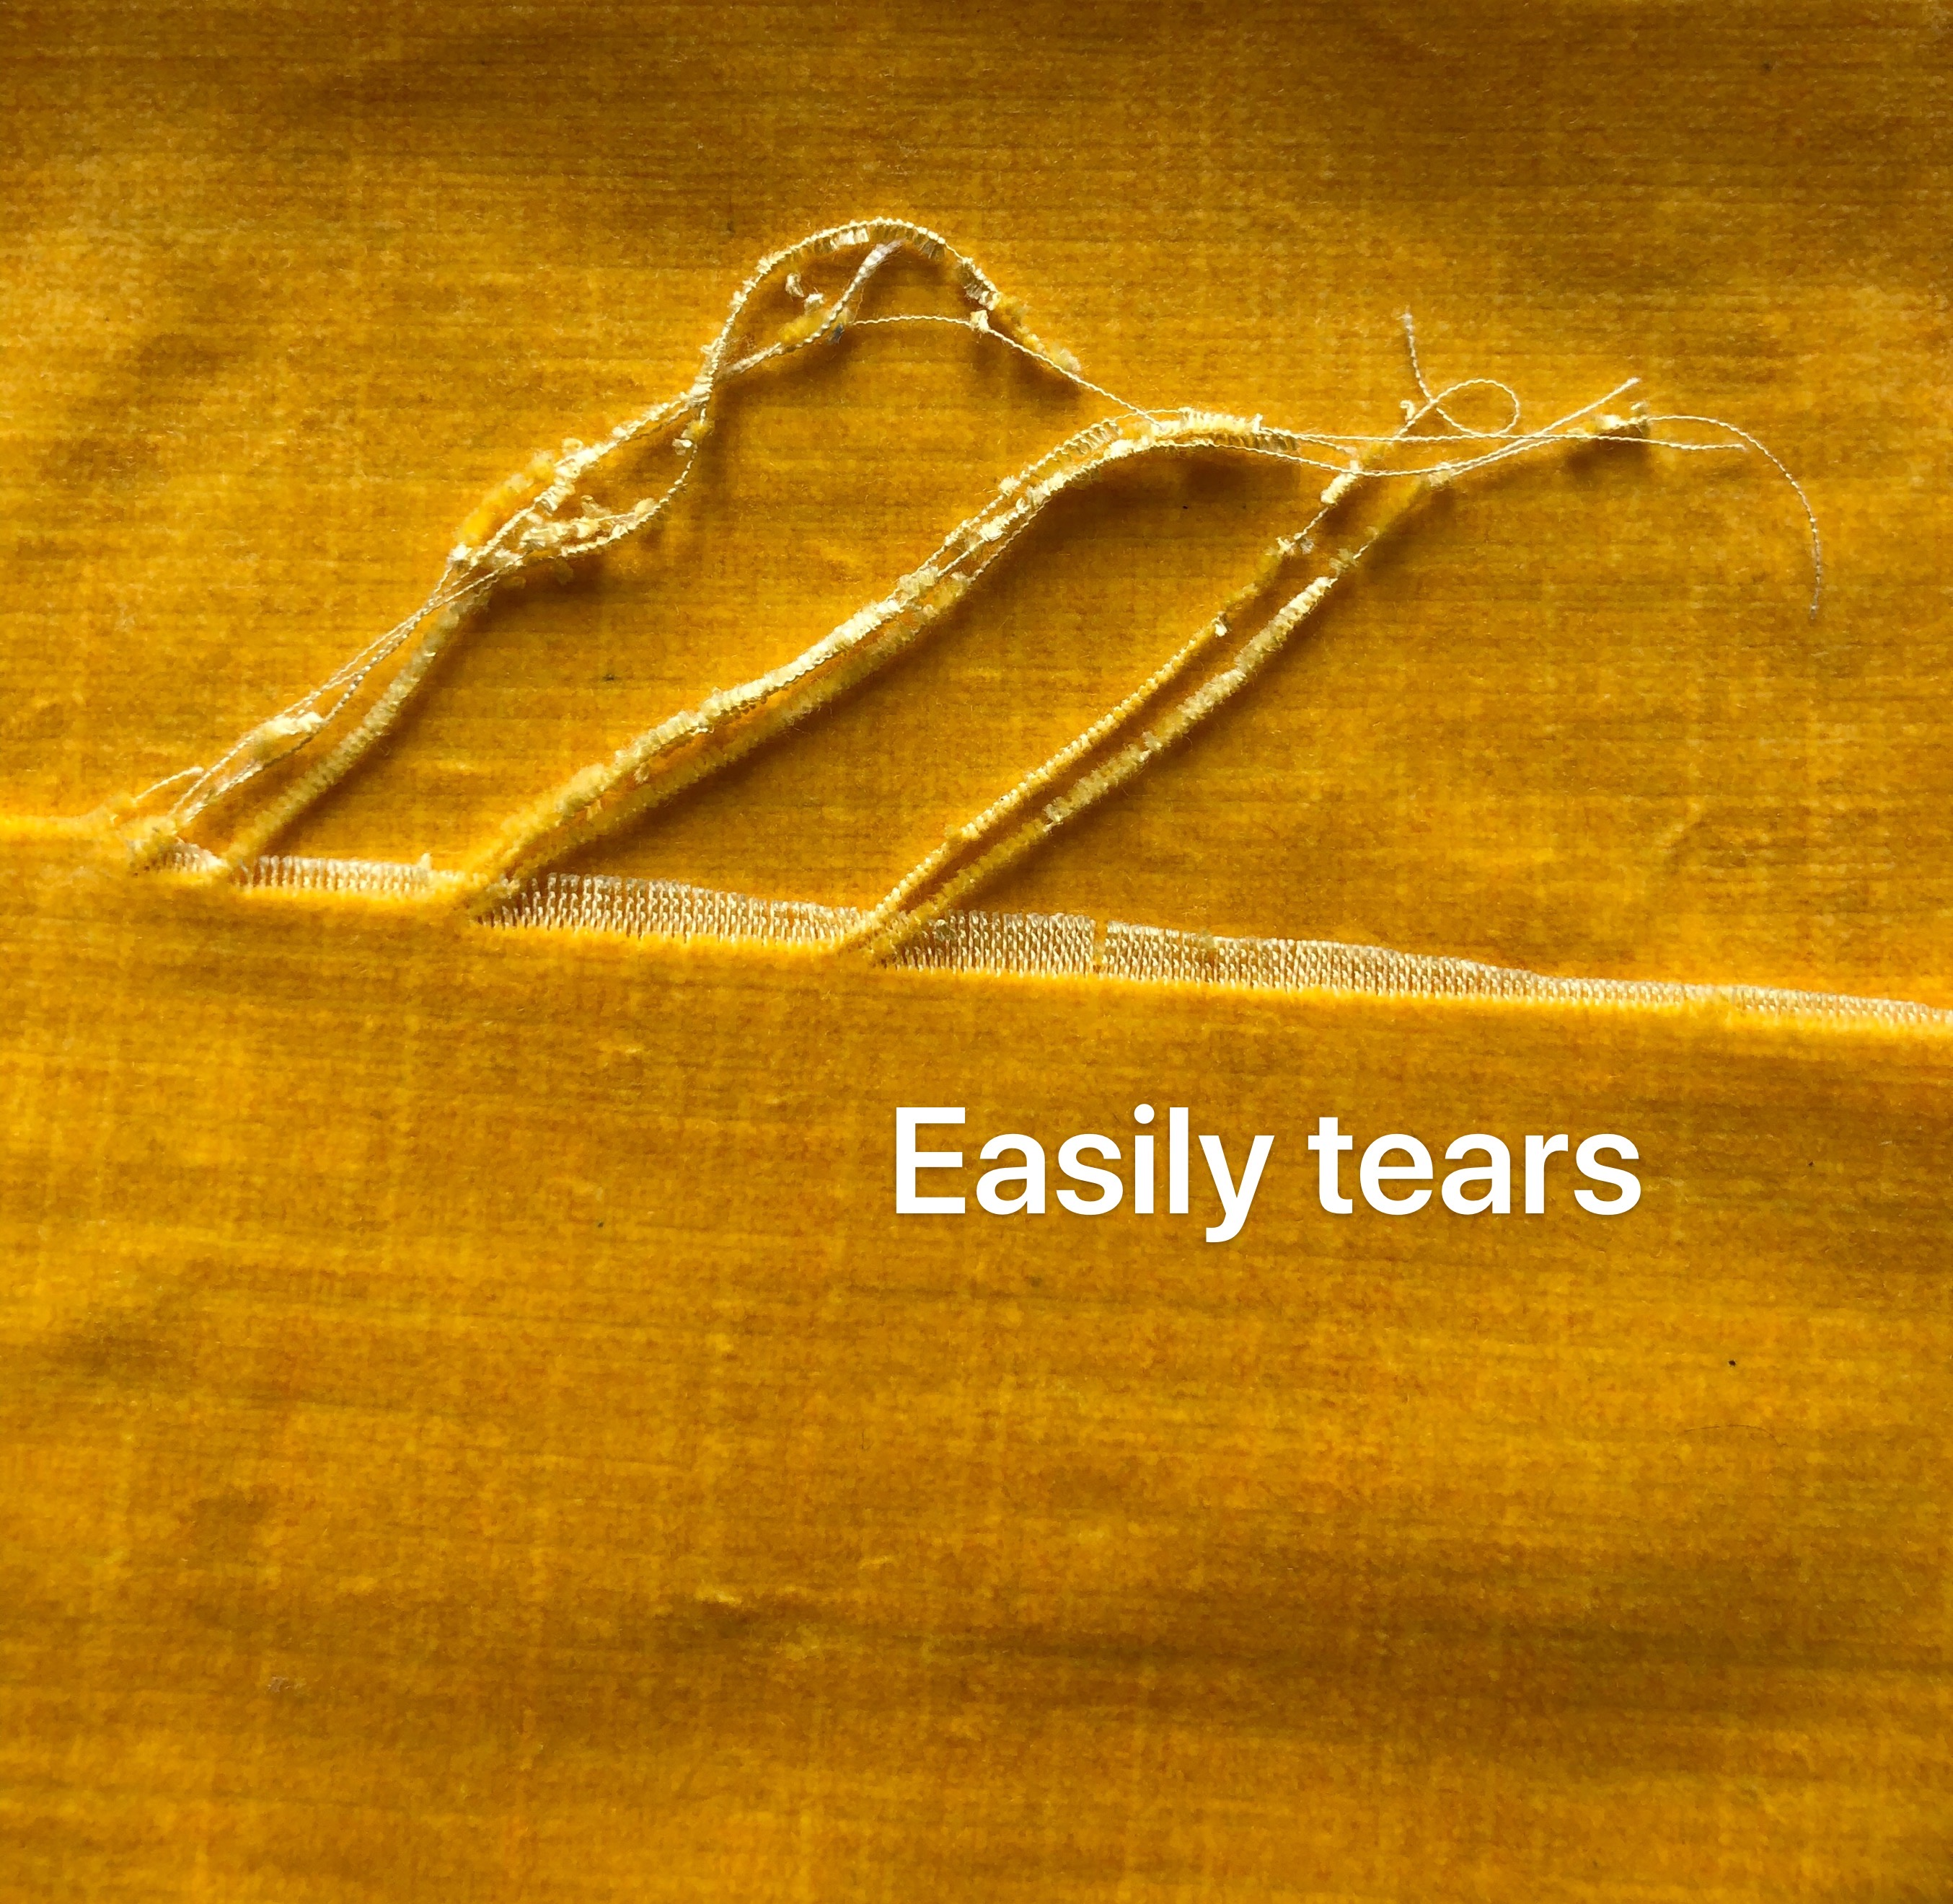

In order to solve the problem of velvet tearing, we consulted a experienced master and summarized the following points that should be paid attention to in the process of making sofa:
1. The margin of each side is about 3cm, which should be set aside during cutting. After the nail put on, cut off the excess fabric, and then stick lace or thread on it.
2. Use No.204 thread and No.17 needle for sewing the hem. Use the synchronous machine.

